Measuring inequality – focusing on people
Daniel Svoboda, Civic Association Development Worldwide, Czech Republic (svoboda@dww.cz)

Summary:
Busan Partnership for Effective Development Cooperation confirmed that poverty and inequality remain the central challenge and that all development actors share common principles, which – consistent with agreed international commitments on human rights, decent work, gender equality, environmental sustainability and disability – form the foundation of cooperation for effective development. Assessment of development outcomes and impacts must focus on sustainable benefits for the target groups (people). Indicators of success (impacts) cannot be imposed by donors but by the target groups themselves, and evaluation results cannot be valid without confirmation by the target groups. The paper focuses on assessment criteria for gender equality aspects.

Keywords: gender, inequality, recognition, enforcement, promoting, empowering, ownership, impact, questions, indicators

Content:

1. Introduction
Busan Partnership for Effective Development Cooperation confirmed that poverty and inequality remain the central challenge and that all development actors share common principles, which – consistent with agreed international commitments on human rights, decent work, gender equality, environmental sustainability and disability – form the foundation of cooperation for effective development.
When speaking about human rights and equality, we must also recognize the difference and complementarity between equality and equity.
For UNICEF “equity means that all children have an opportunity to survive, develop, and reach their full potential, without discrimination, bias or favoritism”. This interpretation is consistent with the Convention on the Rights of the Child (CRC), which guarantees the fundamental rights of every child, regardless of gender, race, religious beliefs, income, physical attributes, geographical location, or other status. Equity is distinguished from equality. The aim of equity-focused policies is not to eliminate all differences so that everyone has the same level of income, health, and education. Rather, the goal is to eliminate the unfair and avoidable circumstances that deprive children of their rights.
(UNCIEF, 2012: Evaluation for equitable development results, page 3)
Gender equality refers to the equal rights, responsibilities and opportunities of women and men, girls and boys. It implies that the interests, needs and priorities of both women and men are taken into consideration, recognizing the diversity of different groups of women and men. Gender equality is not a ’women’s issue’ but concerns, and should fully engage, men as well as women. Equality between women and men, girls and boys is seen both as a human rights’ issue and as a precondition for, and indicator of, sustainable people-centered development. It is also an essential component for the realization of all human rights. Progress toward gender equality requires changes within the family, culture, politics and the economy, in addition to changes in laws and their application.
(UNICEF, 2012: Evaluation for equitable development results, page 14)
In my understanding, the equality mainly refers to equal rights while equity enlarges this concept by equal opportunities. Both aspects are then linked to reducing barriers and to the respect to diversity. Another issue is the quality of equity and equality…
Problem of Official Development Assistance is that all development actors speak about the results but the practice is still often rooted in activity driven approaches and activity-based indicators. This relates also to equality and equity. Assessment of development outcomes and impacts (and related monitoring systems) must focus on sustainable benefits for the target groups (people) and must thus consider four basic pillars for any real success:
- Recognition - existence of human rights based policies and frameworks,
- Enforcement of these frameworks,
- Promoting enabling environment (reducing barriers) for engaging all development actors in development (this aspect relates to inclusion; see UNEG, 2011), and
- Empowering democratic ownership of all development policies and interventions (this aspect relates to participation and fair power relations; see UNEG, 2011).
(UNEG, 2011: Integrating Human Rights and Gender Equality in Evaluation – Towards UNEG Guidance, pages 14-15)
These principles of ownership and participation are valid also for evaluation actions. Indicators of success (impacts) cannot be imposed by donors but must be set by the target groups themselves, and evaluation results cannot be valid without confirmation by the target groups.
In developing countries as well as in all other countries all over the world, there are marginalized groups that do not have (or do not claim) equal rights and opportunities like the rest of the population, they do not have access to basic services, and their voices are put to silence. These groups often include women (but not only women but also girls and children in general), ethnic or religious minorities, disabled people, elder people, rural folks, migrants, homeless people, or youth. It is important to consider all these groups and do not allow “positive discrimination” of only few of them to the detriment of the others. There are specific causes of the problems for each target group, both external and internal. The external causes may include historical conditions (e.g. for the engagement of women), low quality services (e.g. insufficient medical and social care for ill, disabled or elder people), outdated techniques and technologies (for agriculture sector as well as for traditional industries), or poor educational system (with a low quality of education, or not linked with job opportunities). The internal causes are mainly linked with insufficient education, information, and self-confidence in particular, and with limited cooperation within and among these groups and with other development actors.
When assessing inequality, the above mentioned four pillars should be considered for all marginalized or disadvantaged groups:
- Recognition of the problem, of its causes and of possible solutions, as a precondition;
- Enforcement of new policies, as a basic action;
- Promoting active inclusiveness, as a dissemination tool; and
- Empowering self-confidence and ownership, as the required behavior change.
All evaluations of inequality aspects must cover all these levels in evaluation design, questions, methods, as well as in communicating the conclusions and recommendations. Let us discuss the four pillars on the example of gender equality.

2. Example - Gender (in)equality
Millennium Development Goal No. 3 “Promote gender equality and empower women” has three indicators for monitoring progress:
3.1 Ratios of girls to boys in primary, secondary and tertiary education
3.2 Share of women in wage employment in the non-agricultural sector
3.3 Proportion of seats held by women in national parliament
The question is whether these indicators (and their disaggregation by sex and urban/rural as far as possible) can really help in assessing the only valid goal – better lives of women or their families. Reporting of inequalities and differences provides only information on the current status (or the current trend) but cannot describe the causes or the behavior changes:
  - Measuring school attendance cannot identify the reasons why some children do not attend the schools, the quality of education, or the benefits (making use of new skills and knowledge in real life conditions). In addition, this indicator has no ambition to remove the barriers or to provide more incentives (it does not monitor other actors).
  - Measuring employment does not provide the answer on motivations, both of employees (women) and employers, or on positive and adverse impacts of the employment in the given sector (e.g. impacts on health, on family life, or on use of time). Moreover, it does not focus on creating job opportunities or on increasing competitiveness.
  - Proportion of seats in national parliament measures neither motivations of women nor quality of democracy (quality and role of the parliament in the given country).
Evaluation of gender equality, equity (and quality) must consider complexity of these issues and all four pillars of any intervention (policy, program or project); in case the evaluation should address all DAC criteria – from relevance to sustainability of impacts:
  - Recognition of gender issues in laws and policies
This is usually an easy evaluation task; desk review can bring sufficient results for answering yes or no. The relevant indicators for women’s basic political, economic and social rights are included for example in the CIRI Human Rights Data Project (http://www.humanrightsdata.org/). However, more complex evaluation design must be used for the questions why (why yes or why not gender equality is recognized) and how (it is not important how many times the gender equality is mentioned but what is the quality of such legal/policy frameworks). Anyhow, the existence of laws or policies (papers) does not help much if not enforced in practice.
  - Enforcing gender equality – mainstreaming or direct targeting of gender equality (and equity) in practice
Besides the same questions whether the relevant policies are put into the practice, why yes or why not, and how, the evaluators should ask also whether the enforcement is:
  - demand driven (no artificial quotes or whatever external funding can help if the demand is missing) – all gender equality requirements must be operationalized (e.g. when asking for funds or for enabling environment for women groups, we must say for what concretely);
  - result oriented – we must be able to identify the benefits and their sustainability (not only access to provided funds or activities); and
  - inclusive – the benefits cannot serve to exclusive groups (e.g. feminist organizations as intermediaries) but must serve to the target groups (women, their families, children, etc.).
The progress along time in specific indicators (like maternal mortality, literacy rate, employment, etc.) can be well monitored by available data, e.g. the World Bank gender data (http://data.worldbank.org/topic/gender). However, in-depth evaluations at this level must directly work with the target groups; only participatory methods can bring relevant answers.
The key questions are:
- Who are the beneficiaries (men or women, boys or girls, families, where)?
- What are their real problems and needs?
- Did the intervention address the causes of the exclusion?
- What is the theory of change of the given intervention (policy)?
- Who has access to the benefits?
- Are there any unfair conditionalities/barriers?
  - Promoting engagement of men and women, boys and girls in development processes
Even in case there are good policies and good enforcement procedures, these cannot help much if the target groups do not know about them or if they have no capacity to use the benefits. The evaluations at this level should assess:
  - reach of the policies and level of active inclusiveness (e.g. through promoting awareness, capacity building and empowering of excluded groups); and
  - real impacts on gender equality and equity.
The national statistics and other desk review methods must be triangulated by participatory approaches in the field. Only the target groups can define the real impacts on their lives and trustworthy indicators of the intended (or unintended) change. The problem is that monitored literacy or employment (and most of remaining indicators) do not measure impact but only an opportunity (tool) for improving standard of living.
The evaluation questions can include:
- How much do the target groups know about the given intervention?
- What is the real engagement of men and women, boys and girls in the given region?
- What are the internal/external barriers and constraints limiting their engagement (or access to benefits)?
- What measures are taken to increase inclusiveness?
- What are the intended and real impacts?
- Did the use of time by men and women changed as a result of the intervention? How?
- Did the power relations changed as a result of the intervention? How?
- Did the respect between men and women change as a result of the intervention? How?
  - Empowering self-confidence and ownership - True participation of the target groups in all stages of development interventions.
All the above levels of an intervention can bring positive results but can fail in case there is no local ownership or in case that power relations cause favoritism of selected groups. The ownership does not mean the ownership of benefits provided by external actors but must include participation in identifying the needs, formulating the policies and concrete interventions (including indicators of success), and also in monitoring and evaluations.
This pillar works with behavior, attitudes, and motivations. The responses must combine quantitative and qualitative data and these can be hardly found in up-to-date statistics.
The evaluation questions for this level can include:
- Who has the main voice regarding decisions in the households and within communities?
- Who decides about the priorities of development interventions?
- How do the target groups (men and women) participate in setting the indicators or the evaluation questions?
- Does anybody respond to their recommendations?
- Are the target groups prepared to maintain and sustain the benefits?
- Are the men and women satisfied with their roles?
- Do people feel any discrimination regarding their gender?
- What change do they want?
- What own initiatives were launched by the target groups as a follow-up to the given intervention?
- What mistakes they do not want to repeat?
  - Gender indicators - the current approaches
There are hundreds of potential questions related to gender issues, probably hundreds of regularly monitored indicators and many appropriate evaluation methods and approaches. However, can these questions and indicators really provide relevant answers, without artificial biases?
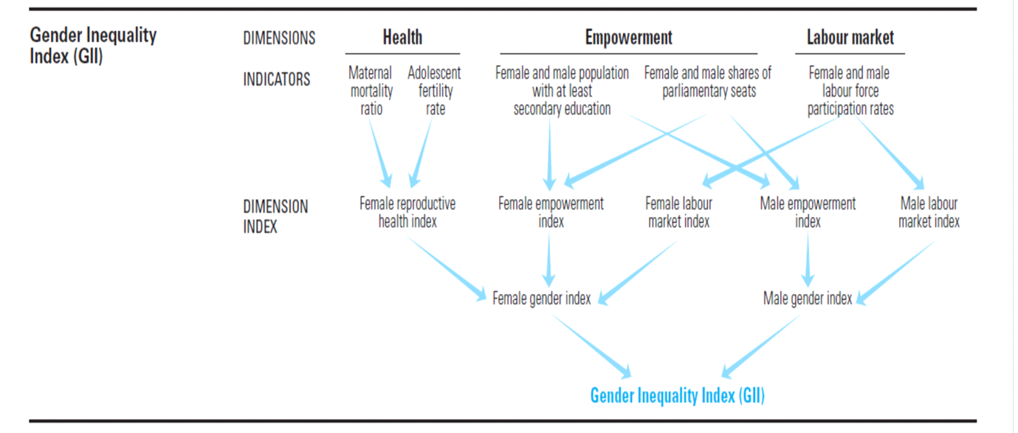One of the generally used indicators is the Gender Inequality Index. It combines female and male gender indexes for the aspects of health, empowerment, and labor market.
However, two female indicators for health are maternal mortality ratio and adolescent fertility rate and there is no equivalent indicator for men. If the input data are not comparable, no mathematical method can provide appropriate comparison between men and women! One of two indicators for empowerment is then female and male shares of parliamentary seats. But this indicator does not include any information what percentage of men and women really want such “job”. We can monitor female and male shares in other sectors (teachers, miners, soldiers, nurses, housekeeping…) and we can get identically biased results and totally different gender indexes – based on the answers we want to hear.
World Bank data (http://data.worldbank.org/topic/gender) related to gender include 54 valuable indicators but none of them describes a behavior change, e.g. the decision making power in the families or trends in using time by men and women. Such disaggregated data by gender are crucially important for indicating the problems but they can recognize neither the real causes of the problems nor the impacts of concrete policies and other interventions.
Inequality-adjusted Human Development Index works with three very relevant dimensions: i) long and healthy life, ii) knowledge, and iii) a decent standard of living.
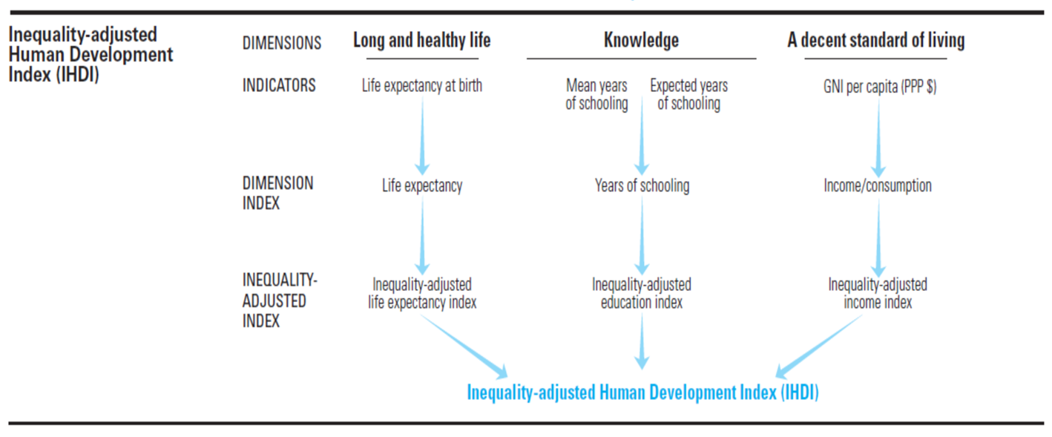However, the indicator of life expectancy can well describe long life but cannot describe how healthy (and happy) the life is. Mean years of schooling then does not recognize the repeaters, or school results - more years in the school does not automatically mean better education, and in addition, better education does not automatically bring better employment or happier life. The last indicator of GNI per capita can be hardly disaggregated by gender or used for specific communities or families. The consumption indicator is a bit better (can be better disaggregated), but the question is who can decide what consumption model is the best.
By the way, one of the key indicators is life expectancy, and the men usually die much earlier than women (in the Czech Republic the life expectancy is 74 years for men and 81 years for women). These data (and the reasons for such a big gap) are not usually reflected in gender focused programs.
  - Summary
The conclusion is that gender policies, programs and projects must have a concrete content, related to the concrete problems and needs of the target groups.
Equality and equity cannot be measured by universal lens, by any whatever sophisticated universal indicator.
Another requirement is that the key indicators must measure a real change in people’s life – attending school only increases the chance but cannot ensure the change of behavior or living conditions.
The complexity of gender issues includes many inter-related aspects, and concerns many actors (besides the CSOs and activists as usual facilitators):
- Issue of maternal mortality definitely needs effective interventions, related both to health services (including infrastructure and equipment) and awareness. These interventions must be primarily focused on girls and women but cannot avoid working also with families, communities and national governments (change of attitudes and behavior is a critical assumption).
- Issue of adolescent fertility needs a lot of awareness and education among both girls and boys but also a lot of advocacy in the regions where family planning and issues of human dignity has a little political support.
- Interventions (or indicators) aiming at education or literacy level cannot stop at primary education level (in most countries the primary education is obligatory, which cannot explicitly guarantee the quality of education), but must focus also on security issues or on income generating activities (allowing the studies) as well as on further use of education, which means either opportunity and ability to continue in secondary, tertiary or vocational education, or opportunity, ability, and right and responsibility of choice of appropriate and decent work. All actors must be included, not only children, families, school staff, communities and local governments but also politicians and the private sector.
- Regarding employment, some generally used indicators (e.g. provided by the World Bank) already refer to the share of the labor force that is without work but available for and seeking employment. The same approach must be used for other indicators like female and male shares of parliamentary seats – it must refer only to the people available for and seeking the seat in the parliament.
3. Conclusions – the way forward
No behavior changes and sustainable benefits can be imposed from outside – by “enlightened” governments, donors, or CSOs. The target groups are the key actors and must be engaged in setting the priorities, in implementation of any development intervention, and in evaluating and maintaining the benefits. The indicators of success must cover the outcome and impact levels, whatever difficult their monitoring is.
Regarding gender equality and equity, the interventions (and indicators) at operational level must be definitely focused on recognizing and removing the external and internal barriers, but the most important indicator should reflect the level of mutual respect between men and women, boys and girls. This can be recognized mainly by sensitive qualitative surveys among the people and by unobtrusive direct observations (or case studies); no proxy indicator can recognize genuine people’s feelings and attitudes.
Other important information should reflect satisfaction of people (men and women) with their roles, recognizing what they really want to change and what they definitely do not want to change. However, such self-decision crucially depends on cognizance of the options and on understanding own chances and own responsibilities.
Education, self-confidence, and learning from own experience (including learning from own mistakes) are thus the key assumptions.
The survey questions for outcome indicators (disaggregated by sex) then could be:
For respect:
- Do you respect that both men and women have the same rights?
- (For men: Do you respect that women have the same rights?)
- (For women: Do you respect that men have the same rights?)
- Do you mind working with men/women?
For discrimination:
- Do you feel any discrimination regarding your gender?
For satisfaction:
- Regarding your gender, are you satisfied with your current role in the community?
For power relations:
- Does your voice matter in your family?
- Does your voice matter in your community?
For empowerment:
- In case you face any gender discrimination, are you ready to initiate any concrete step to change it?
No external pressure (development assistance) can impose happiness as there is no universal definition of happiness and definitely not a universal manual for introducing happiness. Even the most famous experiment with paradise failed – Adam and Eva preferred discovering their own way, with all related problems and unforeseen surprises and failures. On the other hand, they proved that own cognition is much more attractive and much more important than externally provided benefits.
Two last remarks:
Total (gender) equality cannot be reached and must not be enforced. All people are unique human beings with own problems, dreams and motivations. There can be neither happiness nor any progress without diversity and without respect to diversity.
When assessing gender equality, we must consider at least one critical disadvantage of men – they cannot give birth to children. No intervention can change it.

Daniel Svoboda is Geologist-Geophysicist by education, with other key qualifications in environment & health protection, project cycle management and development evaluations. He is Chairman of the Civic Association Development Worldwide, Board member of the Czech Evaluation Society, and member of IDEAS - International Development Evaluation Association (IDEAS Vice-President until April 2012) and of European Evaluation Society. Since 2006, he has been engaged in national and international processes focused on increasing development effectiveness, becoming also member of the Global Facilitation Group of the Open Forum for CSO Development Effectiveness since 2008. Besides other activities in the field of development cooperation and sustainable development (including evaluations of the European Structural Funds or the European program LIFE+), he is also the main organizer of the annual summer school EPDET - European Program for Development Evaluation Training, with a tradition since 2007.

